EXE 2

# **Admin - Login-JobSeekers list**

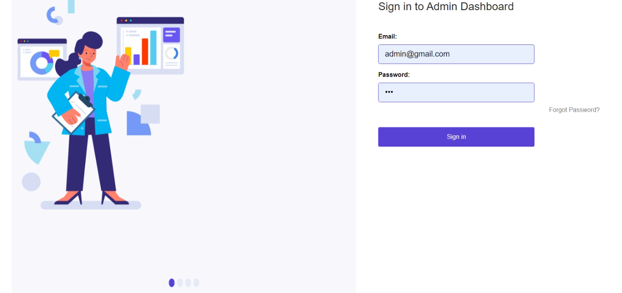

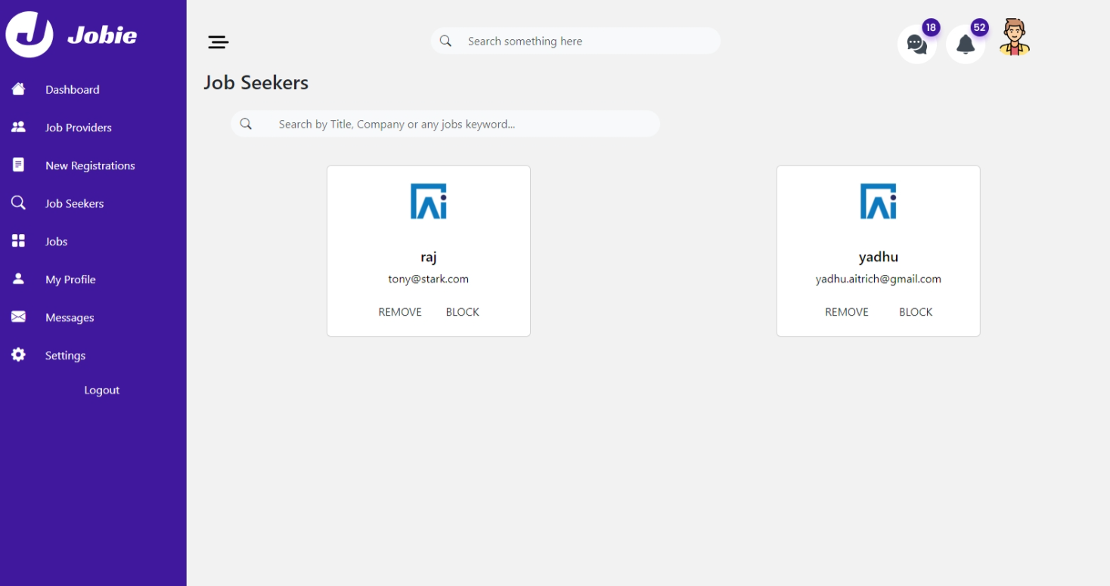

## 

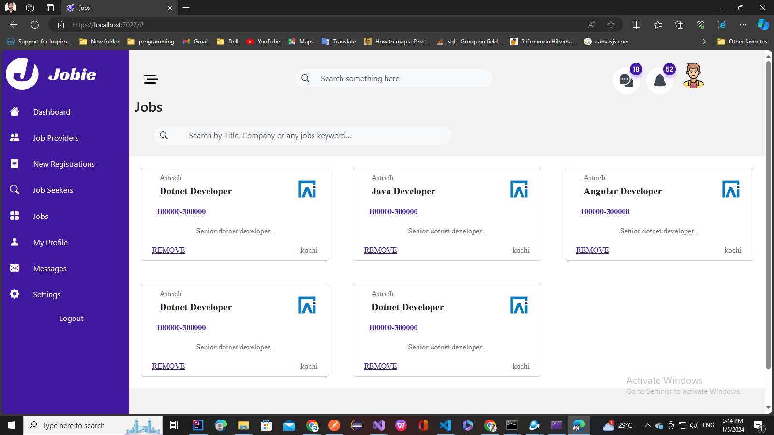

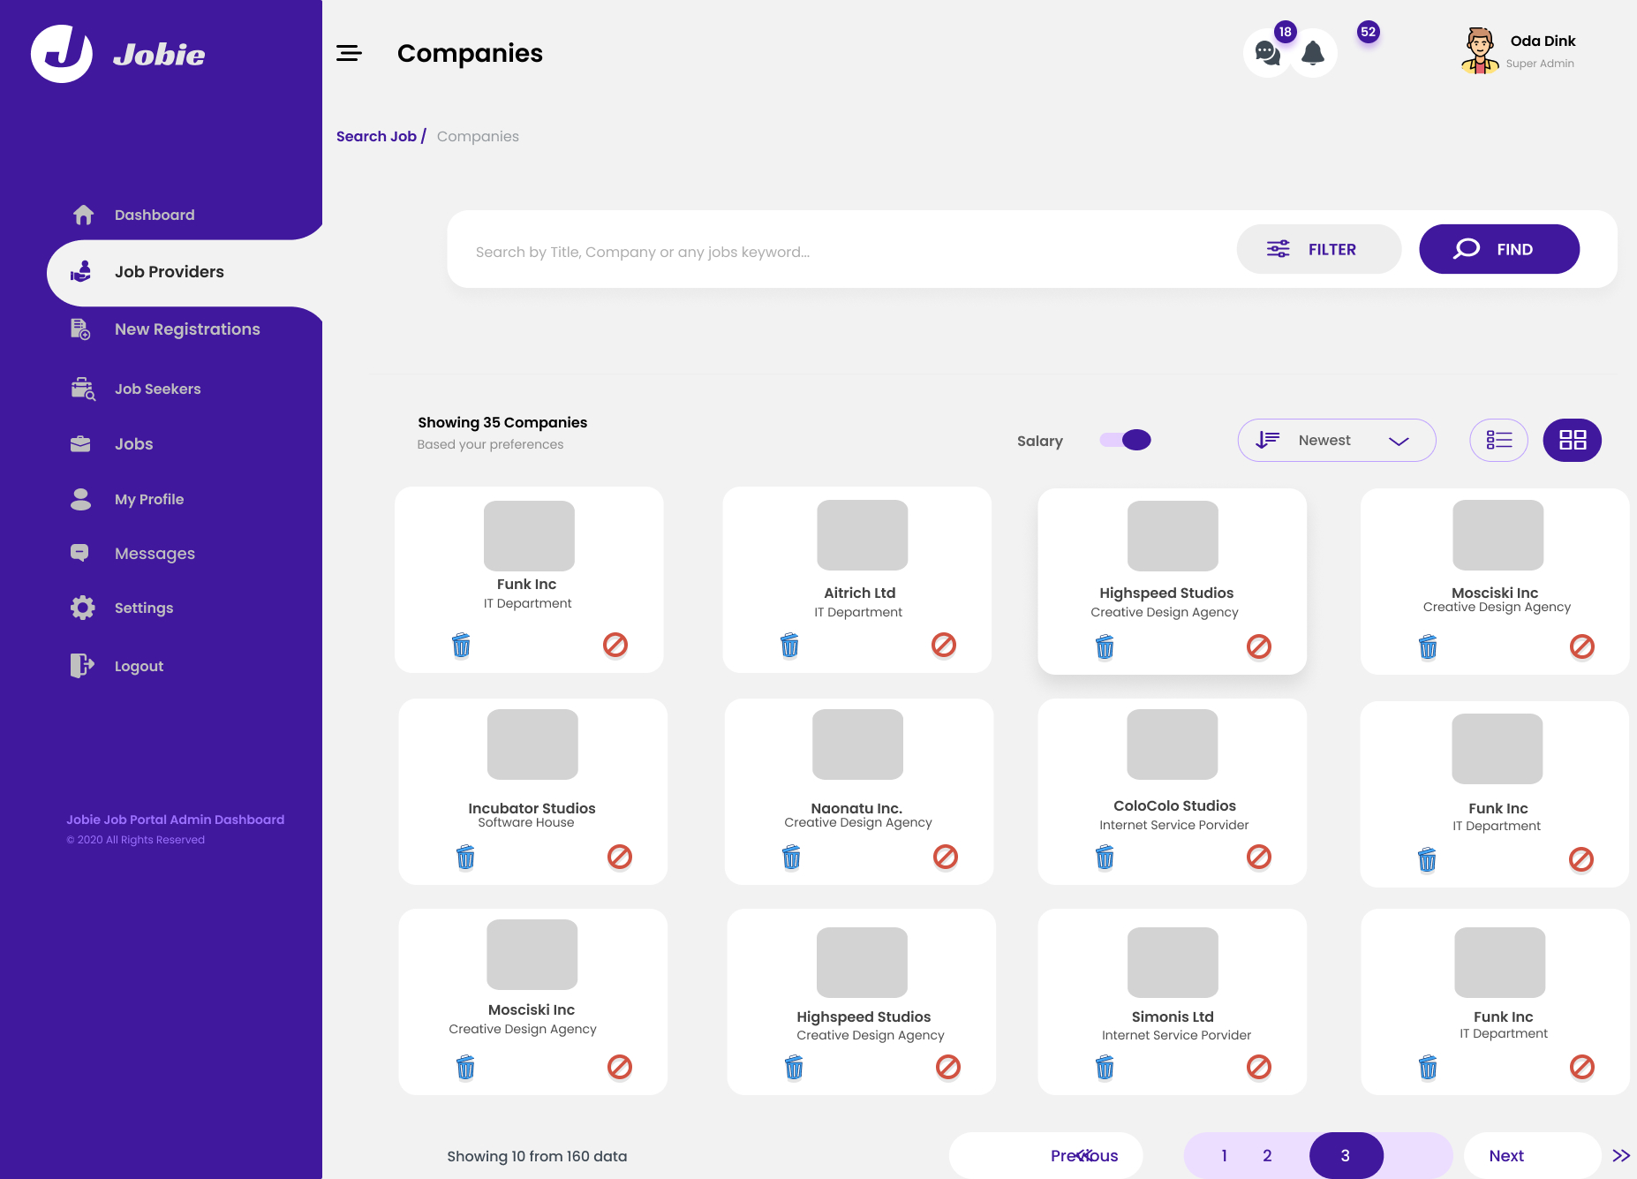

* Design and Implement a login page for admin
* Design and Implement users list as shown above.
* Design and Implement Jobs list page
  + Implement search feature
  + Implement remove feature